Copyright for test papers and marking guides remains with *West Australian Test Papers.*

Test papers may only be reproduced within the purchasing school according to the advertised Conditions of Sale.

Test papers should be withdrawn after use and stored securely in the school until Friday, December 6,



**Human Biology**

**Unit 1 & 2**

**2019**

**Marking Key**

**Multiple Choice Answer Sheet**

For each question shade the box to indicate your answer.

**Suggested working time for this section is 40 minutes.**

|  |  |
| --- | --- |
| **Question** | **Answer** |
| 1 | C |
| 2 | A |
| 3 | B |
| 4 | C |
| 5 | D |
| 6 | D |
| 7 | C |
| 8 | C |
| 9 | C |
| 10 | B |
| 11 | D |
| 12 | D |
| 13 | C |
| 14 | D |
| 15 | B |
| 16 | D |
| 17 | A |
| 18 | B |
| 19 | A |
| 20 | C |
| 21 | B |
| 22 | C |
| 23 | A |
| 24 | A |
| 25 | C |
| 26 | B |
| 27 | D |
| 28 | B |
| 29 | D |
| 30 | D |

**Section Two: Short answer 50% (100 marks)**

This section has **(8)** questions. Answer **all** questions. Write your answers in the spaces provided.

Supplementary pages for the use of planning/continuing your answer to a question have been provided at the end of this Question/Answer booklet. If you use these pages to continue an answer, indicate at the original answer where the answer is continued, i.e. give the page number.

Suggested working time: 90 minutes.

**Question 31**  **(10 marks)**

Cell metabolism is crucial to the survival of cells. Many components of a cell are involved in maintaining cell metabolic activity.

Refer to the following diagram to answer the questions that follow.

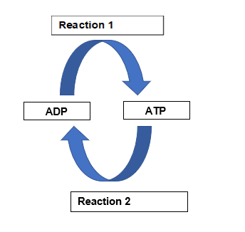

(a) Name a cellular process that will provide the energy for Reaction 1 to occur. (1 mark)

|  |  |
| --- | --- |
| **Description** | **Mark** |
| Respiration/glycolysis/oxidative phosphorylation | 1 |
| **Total** | **1** |

(b) Describe what is occurring in Reaction 2 and identify why this reaction is important to cells. (2 marks)

|  |  |
| --- | --- |
| **Description** | **Mark** |
| Removal of third phosphate/ bond broken between second and third phosphate | 1 |
| Helps release energy from ATP for other cellular processes that require energy | 1 |
| **Total** | **2** |

(c) During vigorous physical activity the body has an increased demand for energy to fuel the contracting muscles. Often this cannot be sustained by the respiratory and circulatory systems.

(i) How then is the body able to generate energy in this situation (1 mark)

|  |  |
| --- | --- |
| **Description** | **Mark** |
| Anaerobic respiration | 1 |
| **Total** | **1** |

(ii) State where this process occurs and what the end product is. (2 marks)

|  |  |
| --- | --- |
| **Description** | **Mark** |
| Cytoplasm | 1 |
| Lactic acid | 1 |
| **Total** | **2** |

(d) Mitochondria are organelles found within the cell. Mitochondria have a specialized structure that enables them to carry out this function. State why having a highly folded inner membrane and a highly permeable outer membrane would assist mitochondria in their function. (2 marks)

|  |  |
| --- | --- |
| **Description** | **Mark** |
| Inner membrane creates a large surface area for reactions to occur | 1 |
| Permeable outer membrane regulates what enters and exits the mitochondria | 1 |
| **Total** | **2** |

(e) Carbohydrates and lipids are important nutrients that can be used to create energy within cells. Explain which of the two is a better energy reserve. (2 marks)

|  |  |
| --- | --- |
| **Description** | **Mark** |
| Fats | 1 |
| 1g of fat releases 38kJ compared to 16kJ from carbohydrates | 1 |
| **Total** | **2** |

**Question 32 (13 marks)**

Some Human Biology students were investigating the effects of drinking various solutions on

their urine output. The two solutions they used were 1 L of plain water and 1L of an isotonic

sodium chloride solution. After drinking the solution, they measured urine output every 30

minutes for 3 hours. Their results are shown below.

|  |  |  |
| --- | --- | --- |
| **Time (min)** | **Urine output (cm3/30 min)** | |
| **Plain water** | **Sodium chloride**  **solution** |
| Start (solutions drunk) |  |  |
| 30 | 40 | 30 |
| 60 | 350 | 40 |
| 90 | 450 | 50 |
| 120 | 250 | 60 |
| 150 | 80 | 50 |
| 180 | 60 | 50 |

(a) Propose a hypothesis for this investigation. (1 mark)

|  |  |
| --- | --- |
| **Description** | **Mark** |
| Statement linking independent and dependent variable | 1 |
| Examples:  Drinking pure water increases urine output/ Adding sodium chloride to a solution has no effect on urine output  Drinking an isotonic salt solution maintains regular urine output |  |
| **Accept any other reasonable answer Total** | **1** |

(b) Identify the following variables for the students’ investigation:

(i) independent variable (1 mark)

|  |  |
| --- | --- |
| **Description** | **Mark** |
| Type of solution | 1 |
| **Total** | **1** |

(ii) dependent variable (1 mark)

|  |  |
| --- | --- |
| **Description** | **Mark** |
| Urine volume/output | 1 |
| **Total** | **1** |

(c) Graph the data on the grid provided. (5 marks)

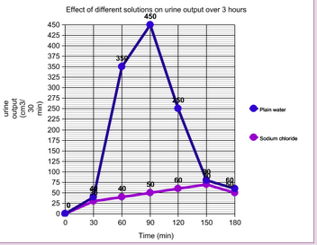

|  |  |
| --- | --- |
| **Description** | **Mark** |
| Title appropriately with both independent and dependent variables included  Correctly constructs axes using appropriate scale (Time on X axis, Urine Output on Y axis)  Labelling of axes with correct name and units  Identifies lines using key/labels  Correctly plots points and joins points to form lines | 1-5 |
| **Total** | **5** |

(d) State two ways in which errors could have occurred that may affect the accuracy of the results. (2 marks)

|  |  |
| --- | --- |
| **Description** | **Mark** |
| Any two of: |  |
| * incorrect readings of volumes/ parallax error * Random error in equipment * Systematic error/error in design of experiment | 1-2 |
| **Total** | **2** |

(e) In humans the average amount of glomerular filtrate formed in one hour is 7L. In one hour the average amount of urine produced is approximately 75mL.

(i) Name the process occurring in the nephron that brings about this difference in volume. (1 mark)

|  |  |
| --- | --- |
| **Description** | **Mark** |
| Selective reabsorption/osmosis | 1 |
| **Total** | **1** |

(ii) Explain why the process identified in part (i) must occur in the human body

(2 marks)

|  |  |
| --- | --- |
| **Description** | **Mark** |
| Water is a useful substance needed by the body so is reabsorbed back into the blood. | 1 |
| to prevent dehydration./ to allow cellular processes to occur | 1 |
| **Total** | **2** |

**Question 33 (14 marks)**

Shown below is a pedigree that outlines the inheritance of a particular disease within a family.

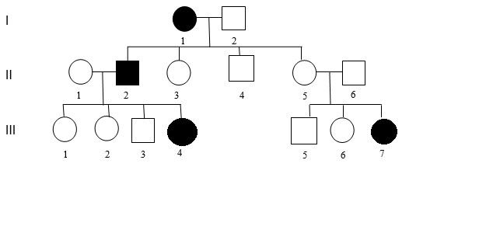

(a) Using evidence from the pedigree, explain why the disorder cannot be transmitted by a sex-linked recessive gene. (2 marks)

|  |  |
| --- | --- |
| **Description** | **Mark** |
| If sex linked then an affected female such as I1 would pass it on to her son II4, but he is not affected | 1 |
| III7 is affected but II6 is not | 1 |
| **Total** | **2** |

(b) Using evidence from the pedigree, explain why the disorder cannot be transmitted by an autosomal dominant gene. (2 marks)

|  |  |
| --- | --- |
| **Description** | **Mark** |
| If it was autosomal dominant then two unaffected parents could not have an affected child | 1 |
| II 5 and II6 are unaffected which means they do not have the dominant allele but they have produced an affected offspring III7 | 1 |
| **Total** | **2** |

(c) Assume that the individual II 1 has a genotype **Bb**. Individuals II 1 and II 2 have another child.

What is the probability that it will be an affected daughter? Show your working.

(4 marks)

PI Bb x bb

B b

|  |  |
| --- | --- |
| Bb | bb |
| Bb | bb |

b

b

2 Bb: 2 bb

|  |  |
| --- | --- |
| **Description** | **Mark** |
| * Correct genotypes of parents listed * Correct genotypes of potential offspring inside Punnett square | 1  1 |
| Probability of producing a daughter with disease = ½ x ½  = ¼ or 0.25 | 1  1 |
| **Total** | **4** |

(d) Which male in generation 3 is more **unlikely** to pass on the allele to his future children? Explain your reasoning. (3 marks)

|  |  |
| --- | --- |
| **Description** | **Mark** |
| III5 | 1 |
| II3 must have one b allele as they have an affected parent therefore the probability of passing it on to his children is 50% | 1 |
| III5 could be BB or Bb therefore the chance of passing the b on to his children lower/less than III3 | 1 |
| **Total** | **3** |

(e) If ll5 becomes pregnant again describe **one** prenatal test this couple could have to find out the genotype of the unborn child and state **one** risk associated with this method of prenatal testing. (3 marks)

|  |  |
| --- | --- |
| **Description** | **Mark** |
| **Any one of the following examples.** |  |
| **1. Amniocentesis**  Removal of amniotic fluid (16th-20th week pregnancy) from amniotic sac – about 10 – 20 ml  Foetal cells in fluid examined | 1-2 |
| Risk- infection, miscarriage or damage to baby | 1 |
| **2. Chorionic villus sampling**  Obtain foetal cells from chorion using needle aspiration.  Cells examined in the same way as amniocentesis | 1-2 |
| Risk- miscarriage | 1 |
| **3. Foetal blood sampling**  obtain foetal blood samples from placenta | 1-2 |
| Risk of infection / bleeding from sample site / leaking of amniotic fluid / miscarriage / change in foetus heart rate | 1 |
| **Total** | **3** |

**Question 34 (11 marks)**

Paternity testing involves a number of procedures used to determine the biological father of a child. One of these is testing for blood groups while the other looks at DNA profiling.

The following shows the results of these two procedures.

**Procedure 1: Testing for ABO blood groups**

Mother’s blood group: B

Childs blood group: O

Possible biological father’s blood groups – Father 1: O, Father 2: A, Father 3: B

**Procedure 2: DNA profile data**

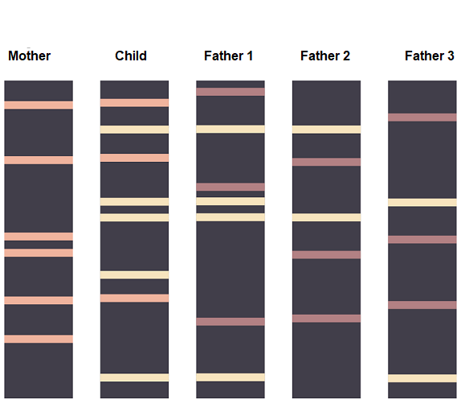

(a) (i) From the ABO blood group data, identify which male(s), can be excluded as the possible biological father of the child. (1 mark)

|  |  |
| --- | --- |
| **Description** | **Mark** |
| None | 1 |
| **Total** | **1** |

(ii) Using Punnett squares show how you arrived at your answer in part (a)(i). (4 marks)

**Possible father 1**

Father

Mother

|  |  |  |
| --- | --- | --- |
|  | i | i |
| IB | IB i | IB i |
| i | ii | ii |

**Possible father 2**

Father

Mother

|  |  |  |
| --- | --- | --- |
|  | IA | i |
| IB | IAIB | IBi |
| i | IAi | ii |

**Possible father 3**

Father

Mother

|  |  |  |
| --- | --- | --- |
|  | IB | i |
| IB | IBIB | IBi |
| i | IBi | ii |

|  |  |
| --- | --- |
| **Description** | **Mark** |
| 1 mark per Punnett square | 3 |
| All fathers could produce an O blood group child | 1 |
| **Total** | **4** |

(b) Describe the process that produces DNA profile data.

(4 marks)

|  |  |
| --- | --- |
| **Description** | **Marks** |
| **Any 4 of the following** |  |
| * DNA cut by restriction enzymes * Sections of DNA / DNA pieces placed at one end of gel bed * Buffer solution bathes gel * Electric current is passed through the gel / voltage applied * Negatively charged DNA moves towards positive electrode / terminal * DNA moves through the gel at different speeds / smaller moves faster than larger * Bands form representing different size fragments of DNA | 1-4 |
| **Total** | **4** |

(c) Using the data from the DNA profile suggest which of the fathers is the actual father of the child. Explain how you arrived at your answer. (2 marks)

|  |  |
| --- | --- |
| **Description** | **Mark** |
| Possible father 1 | 1 |
| Only father 1 has matching bands in places where mother’s bands do not match those of the child. | 1 |
| **Total** | **2** |

**Question 35 (11 marks)**

(a) On the diagram of the heart shown below, label the aorta, the pulmonary artery and the right ventricle. (3 marks)

|  |  |
| --- | --- |
| **Description** | **Marks** |
| Aorta correctly labelled | 1 |
| Pulmonary artery correctly labelled | 1 |
| Right ventricle correctly labelled | 1 |
| **Total** | **3** |

Aorta

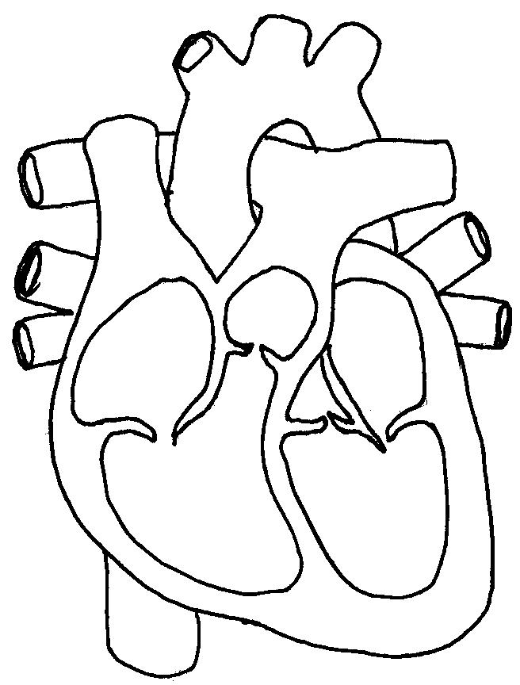

Right

ventricle

Pulmonary artery

(b) All babies are born with a “hole in their heart” that closes over once the lungs inflate with oxygen. What name is given to this structure?

(1 mark)

|  |  |
| --- | --- |
| **Description** | **Mark** |
| Foramen ovale | 1 |
| **Total** | **1** |

Occasionally a baby is born with a serious condition of the heart. There are separate abnormalities within the heart that occur as a result of this condition including that the aorta comes primarily out of the right ventricle instead of the left and the muscular wall between the right and left sides of the heart is incomplete, so the blood in the left and right ventricles is not kept separate.

(c) In a baby with the condition described above, is the hole between the ventricles an advantage or a disadvantage? Explain your choice. (3 marks)

|  |  |
| --- | --- |
| **Description** | **Marks** |
| Advantage | 1 |
| Hole allows for some mixing of oxygenated and deoxygenated blood to go to right ventricle | 1 |
| This blood that does contain some oxygen can then be pumped to the body via the misplaced aorta. | 1 |
| **Total** | **3** |

(d) Many vital organs of a foetus are not required to function whilst it is carried in the uterus. After birth, however, rapid changes need to occur within the foetal circulation to enable the baby to survive outside the womb. Outline **two** major changes (besides the hole in the heart closing), that will occur.

(4 marks)

|  |  |
| --- | --- |
| **Description** | **Marks** |
| Blood flow through ductus arteriosus (lung bypass) decreases | 1 |
| Blood now flows to the lungs via the pulmonary artery | 1 |
| Blood flow through ductus venosus (liver bypass) decreases | 1 |
| Blood starts to flow through the liver and returns to heart via the inferior vena cava | 1 |
| **Total** | **4** |

**Question 36 (12 marks)**

(a) Sketch a graph that shows the changes in thickness of the uterine wall throughout one complete menstrual cycle. Indicate on the graph when ovulation occurs. (2 marks)

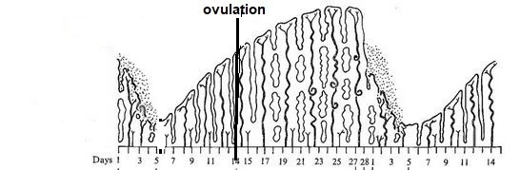

|  |  |
| --- | --- |
| **Description** | **Marks** |
| Shows gradual increase in thickness up to day 28/ shows a decrease in thickness for days 1-7 | 1 |
| Labels ovulation correctly at day 14. | 1 |
|  |  |
| **Total** | **2** |

(b) Describe how the following hormones affect the uterine lining during the monthly cycle.

(2 marks)

(i) Progesterone

|  |  |
| --- | --- |
| **Description** | **Marks** |
| **Any one of** |  |
| Endometrium continues to thicken  Glands secrete mucous  Drop in progesterone induces menstruation  Becomes more vascularised/glandular | 1 |
| **Total** | **1** |

(ii) Oestrogen

|  |  |
| --- | --- |
| **Description: any of** | **Marks** |
| Inhibits menstrual flow  Endometrium thickened/becomes softer | 1 |
| **Total** | **1** |

(c) How does fertilisation of an egg alter the hormonal regulation of the menstrual cycle?

(5 marks)

|  |  |
| --- | --- |
| **Description -any of** | **Marks** |
| Corpus luteum continues to secrete progesterone and oestrogen | 1 |
| Endometrium is maintained | 1 |
| This inhibits secretion of FSH | 1 |
| From pituitary | 1 |
| No more follicles in ovary begin to mature | 1 |
| **Total** | **5** |

(d) About 1 in 6 couples in Australia wanting to have children experience difficulties in getting pregnant. Advancements in reproductive technology have resulted in a range of treatments for infertility being made available. One such assisted reproductive technology is GIFT. (1 mark)

(i) What does GIFT stand for?

|  |  |
| --- | --- |
| **Description** | **Marks** |
| Gamete Intra fallopian transfer | 1 |
| **Total** | **1** |

(ii) Describe how this procedure takes place. (2 marks)

|  |  |
| --- | --- |
| **Description** | **Marks** |
| eggs and sperm mixed together immediately after eggs are collected | 1 |
| Injected into woman’s fallopian tubes | 1 |
| **Total** | **2** |

**Question 37 (18 marks)**

(a) Starting just after birth, cartilage found within bones is progressively replaced by bone.

(i) What name is given to this process? (1 mark)

|  |  |
| --- | --- |
| **Description** | **Marks** |
| Ossification | 1 |
| **Total** | **1** |

(ii) How can we use the epiphyseal cartilage found inside long bones to determine when this process is complete? (3 marks)

|  |  |
| --- | --- |
| **Description** | **Marks** |
| When bone in epiphysis meets bone in the diaphysis | 1 |
| The epiphyseal line is the only remnant that remains of cartilage within the bone | 1 |
| This signifies that ossification is complete | 1 |
| **Total** | **3** |

The diagram below shows the bones found within the leg.

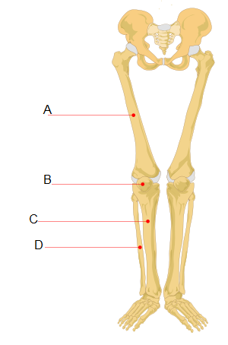

(b) Name the bone labelled A and state in which section of the skeleton you would find this bone. (2 marks)

|  |  |
| --- | --- |
| **Description** | **Marks** |
| A: femur | 1 |
| Appendicular | 1 |

(c) People often think that bone is dead. Explain why this is not a true statement. (2 marks)

|  |  |
| --- | --- |
| **Description: Any 2 of the following** | **Marks** |
| Bone is a tissue | 1 |
| Bone contains live bone cells/blood vessels/nerves | 1 |
| Bone is metabolically active | 1 |
| **Total** | **2** |

The movements at any particular joint are possible because of its structure, the location of ligaments and tendons, and the skeletal muscles that contract to pull the bone into a different position.

(d) The knee joint is an example of a synovial joint. What are **two** characteristics of all synovial joints? (2 marks)

|  |  |
| --- | --- |
| **Description** | **Mark** |
| Any two of: |  |
| * Freely moveable * Contain synovial fluid * Have a synovial cavity * Have an articular capsule | 1-2 |
| **Total** | **2** |

(e) (i) Define the term ligament. (1 mark)

|  |  |
| --- | --- |
| **Description** | **Marks** |
| Tissue that joins bone to bone | 1 |
| **Total** | **1** |

(ii) Explain why tendons need to be inelastic. (3 marks)

|  |  |
| --- | --- |
| **Description** | **Mark** |
| **Any 3 of the following** |  |
| * Tendons attach muscle to bone * Do not stretch when muscle contracts * All force is transferred to bone * Bone is then moved | 1-3 |
| **Total** | **3** |

(f) Muscle contraction is often explained by using the sliding filament model. Describe what would occur within a sarcomere to produce contraction.

(4 marks)

|  |  |
| --- | --- |
| **Description : Any 4 of the following** | **Marks** |
| Thin actin slides over thick myosin/ myofilaments overlap | 1-4 |
| Mysoin heads bond to actin/ cross bridges form |
| Myosin heads pull on actin filaments |
| Z lines move closer together |
| Sarcomere shortens/muscle fibre shortens |
| **Total** | **4** |

**Question 38 (11 marks)**

1. DNA is made of units called nucleotides. Draw a labelled diagram of a nucleotide to show its constituent parts. (3 marks)

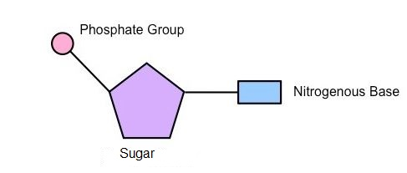

|  |  |
| --- | --- |
| **Description** | **Marks** |
| Sugar, phosphate and base labelled correctly | 1 |
| One base connected to sugar AND one phosphate connected to the other side of the sugar | 1 |
| Only a single nucleotide drawn/ correct representation of a single nucleotide | 1 |
| **Total** | **3** |

1. Which of the labelled part/s in your diagram may vary from nucleotide to nucleotide?

(1 mark)

|  |  |
| --- | --- |
| **Description** | **Marks** |
| Nitrogenous base | 1 |
| **Total** | **1** |

DNA codes for the sequence of amino acids in a protein. The diagram below shows a section of a DNA strand.

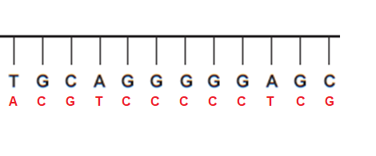

(c) (i) Use the base pair rule to create the complementary DNA strand. Draw it on the diagram above. (1 mark)

(1 mark for correct strand - see above)

(ii) Write down the strand that would be produced from the DNA template to form mRNA. (1 mark)

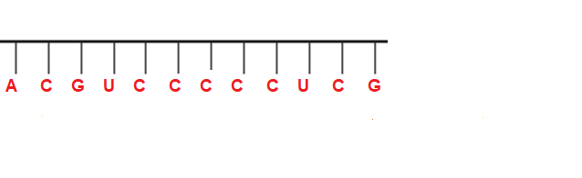

(d) Describe in detail how mRNA is created from the DNA template strand. (5 marks)

.

|  |  |
| --- | --- |
| **Description -any 5 of** | **Marks** |
| * DNA unwinds/unzips/ helicase unwinds DNA | 1-5 |
| * DNA code is used as a template |
| * RNA polymerase involved |
| * mRNA forms complementary strand to DNA template strand |
| * uracil instead of thymine attached to adenine [C - G, A - U not T] |
| * free nucleotides used to form mRNA |
| **Total** | **5** |

**Section Three: Extended answer 20% (40 Marks)**

This section contains **three** questions. You must answer **two** questions. Write your answers on the pages following Question 41.

Supplementary pages for planning/continuing your answers to questions are provided at the end of this Question/Answer booklet. If you use these pages to continue an answer, indicate at the original answer where the answer is continued, i.e. give the page number.

Suggested working time: 50 minutes.

**­­­­­­­­­­­­­­­­­­­­­­­____________________________________________________________________________**

**Question 39 (20 marks)**

(a) In the human body the functioning of the different body systems is closely related to the structure of the tissues and organs that connect together to create the system. For each of the following describe the structure of the component and identify how the structure is responsible for the functioning of the system in which it is found. (12 marks)

(i) Alveolus

(ii) Nephron

(iii) Villus.

|  |  |  |
| --- | --- | --- |
| **Component** | **Description** | **Mark** |
| Alveolus | **Structure : Any two of the following**   * Thin single celled/simple squamous epithelial cells * Highly permeable membrane * Highly vascularised/surrounded by capillaries * Moist | 1-2 |
|  | **Functioning: Any two of the following**   * Site of gas exchange * Allows for diffusion of gases * High surface area to volume ratio to allow for rapid diffusion of gases * Close association with capillaries to allow for gas transfer | 1-2 |
| Nephron | **Structure: Any two of the following**   * Comprised of renal tubules and glomerulus/renal corpuscle * Surrounded by blood vessels/ peritubular network * DCT of different nephrons join into collecting ducts | 1-2 |
|  | **Functioning: Any two of the following**   * Filtration of substances from the blood * Reabsorption of essential materials (such as glucose and amino acids) * Tubular secretion of materials(such as penicillin/ H+) * Creates urine * Removes metabolic wastes | 1-2 |
| Villus | **Structure : Any two of the following**   * Finger like/hair-like projections * Has microvilli * Single cell layer/simple columnar epithelium * Capillary bed and lacteals * Contains goblet cells | 1-2 |
|  | **Functioning: Any two of the following**   * Large SA to increase absorption * Absorbs water by osmosis into capillaries * Absorbs amino acids/glucose by active transport into blood * Absorbs fatty acids and glycerol/ fat soluble vitamins into lacteals * Secretes mucous to allow for peristalsis * Peristalsis moves food through alimentary canal. | 1-2 |
|  | **Total** | 12 |

(b) Enzymes are involved in chemical reactions that occur within cells. Explain why there is a need for so many different enzymes in the body and outline how they work. (8 marks)

|  |  |
| --- | --- |
| **Description**  **So many needed because** | **Marks** |
| One enzyme will combine with only one substrate | 1 |
| therefore is involved in one reaction only | 1 |
| Body produces many different enzymes due to many reactions it performs. | 1 |
| **How they work-Any 5 of the following** |  |
| Enzymes reduce/lower the activation energy required for a chemical reaction to proceed. | 1 |
| Lock and key model | 1 |
| Substrate binds with enzyme at active site | 1 |
| Forms enzyme-substrate complex | 1 |
| Enzyme remains unchanged | 1 |
| Enzymes can use induced fit model | 1 |
| **Total** | **8** |

**Question 40 (20 marks)**

(a) Movement or motion takes place as a coordinated action between muscles, bones and joints. Describe in detail how the processes of flexion and extension occur at the elbow joint. (12 marks)

|  |  |
| --- | --- |
| **Description** | **Marks** |
| Biceps and triceps are antagonistic pair/ work in opposition to each other | 1 |
| Elbow joint is a hinge joint | 1 |
| Muscles pull on bones to create movement | 1 |
| Synergistic muscle around the elbow help stabilise it during flexion and extension | 1 |
| **Flexion** | |
| Any four of: | |
| * Biceps contracts/flexes * Triceps relaxes * Biceps pulls on tendon attached to radius * Lower arm moves upwards/angle between bones reduced | 1–4 |
| **Extension** | |
| Any four of: | |
| * Triceps contracts/flexes * Biceps relaxes * Triceps pulls on tendon connected to ulna * Lower arm moves down/angle between bones increases | 1–4 |
| **Total** | **12** |

(b) Stem cells are promoted as “the way of the future” for the treatment of many illnesses. Define the term stem cell and explain **three** the differences between adult and embryonic stem cells. (8 marks)

|  |  |
| --- | --- |
| **Definition– any 2 of the following** | **Marks** |
| Cell that is not specialised. | 1 |
| Cell capable of repeated mitosis. | 1 |
| Cell can differentiate into specialised cells. | 1 |
| **Total** | **2** |
| **Differences- any 3 linked differences** |  |
| Adult cell- multipotent. | 1 |
| Embryonic- pluripotent. | 1 |
| **Total** | **2** |
| Embryonic stem cell cultured from frozen embryos. | 1 |
| Adult stem cell taken from adult tissue/s. | 1 |
| **Total** | **2** |
| Embryonic stem cell may be rejected by recipient’s body. | 1 |
| Adult stem cells are not rejected | 1 |
| **Total** | **2** |
| More ethical issues linked to use of embryonic stem cells. | 1 |
| Cells derived from patient’s own tissue so no real ethical concerns. | 1 |
| **Total** | **2** |
| **Accept any other valid answers** |  |
| **Total** | **8** |

**Question 41 (20 marks)**

(a) During pregnancy a vital structure called the placenta is formed that provides a link between the foetus and the mother. Explain the functions of the placenta during pregnancy. (8 marks)

|  |  |
| --- | --- |
| **Description**  **Any of the following- Must have explanation to gain mark not just a list of functions** | **Marks** |
| Secretes hormones (HCG,progesterone,oestrogen) that maintain pregnancy. | 1 |
| Removes wastes by transporting urea, uric acid and ammonia from foetus to mother’s kidneys. | 1 |
| Allows for transmission of antibodies from mother to foetus to give foetus immunity from pathogens/disease. | 1 |
| Transports nutrients such as glucose and amino acids to foetus for growth. | 1 |
| Stores essential nutrients to release later on when demand for them by foetus is greater. | 1 |
| Transports oxygen from mother to foetus to enable cell respiration to occur in the foetus’ cells. | 1 |
| Transports waste products of cell respiration/carbon dioxide from foetus to mother so it doesn’t poison cells. | 1 |
| Increases surface area available for exchange of wastes and nutrients so that faster diffusion will occur. | 1 |
| **Total** | **8** |

(b) Modern science has introduced new and highly reliable methods of birth control or contraception. A condom is a mechanical barrier whilst the oral contraceptive pill is a chemical method. Discuss in detail how each of the named contraceptives work to prevent pregnancy,and the advantages and disadvantages of each. (12 marks)

|  |  |
| --- | --- |
| **Description** | **Marks** |
| Pill: any 3 of the following   * Hormones taken in pill form for 21 days * Substitute hormones prevent release of mature egg from ovary * Cervical mucus becomes thick and sticky so sperm unable to travel to uterus * Alter lining of the uterus so less receptive to embryo implanting. | 1-3 |
| Condom: any 2 of the following   * Made of rubber * Rolled onto penis before intercourse * Prevents semen from entering vagina | 1-2 |
| A Pill advantages:any 2 of the follwoing   * reduce PMT * reduce menstrual cramps * reliable * reduced incidence of cervical and ovarian cancer * convenient | 1-2 |
| Condom advantages: any 2 of the following   * Easy to buy * Cheap * Reliable if used correctly * Protects against STI’s | 1-2 |
| Pill disadvantages- any 2 of the following   * Must be taken ot same time each day * Can have side effects * Need to get a prescription * Some are expensive | 1-2 |
| Condom disdvantages any of the following   * May affect spontaneity * May reduce male sensation * Both partners have to be cooperative | 1 |
| **Total** | **12** |

**End of examination**

**End of questions**